Friday, May 6, 2022

***Saikumar Yaramasu***

801 S Walnut Street, Maryville

Missouri – 64468

Dear Saikumar,

# SUBJECT: Offer Letter

We are pleased to offer you a fulltime internship as a “**Software Developer**” with **Tekfinite Inc.** We invite you to start internship with the Company under the following terms and conditions:

1. **START DATE:** The work assignment as a **Software Developer** starts on May 10, 2022.
2. **DUTIES:** You are expected to work 20 hours in a week. You shall use your best energies and abilities to perform the internship duties assigned to you, at location designated by the Company. You are working on an at-will basis and shall comply with all rules, regulations, and procedures of the Company. You shall provide weekly status reports concerning your work activities as requested.

Your job duties as a **Software Developer** will be as listed below.

* Robust critical thinking skills coupled with a desire for growth, to learn and to engage with peers in technical and design discussions.
* Demonstrated experience in communicating technical needs and capabilities to non-technical team members, product owners, and partners.
* Enterprise application architecture patterns and orchestration frameworks such as Apache Camel.
* Client-side unit testing frameworks and test runners like Jasmine and Karma.
* Ability to utilize a long-term mentality to help produce scalable, maintainable solutions.
* Passion to provide guidance on standard methodologies and mentoring support to the other Developers within the wider Digital Platforms Technology team.
* Experience collaborating in a team environment to develop, deploy, and support key applications and features.
* A demonstrable understanding of the Agile software development methodology.
* Extensive experience decomposing sophisticated business problems into creative, efficient, and scalable solutions.
* Appreciation for and alignment to standard methodologies regarding object-oriented design, coding standards, RESTful service consumption and integration, common design patterns, secure application development, and test coverage.

During your internship, you shall not directly or indirectly usurp any corporate opportunities or otherwise engage in any conduct adverse to the best interest of the Company. You shall not divulge any confidential information of, or violate any agreement with, your prior employers or their clients.

1. **TERMINATION:** You agree to provide the Company with two (2) weeks advance notice of termination and, except in cases of termination by the Company due to your willful misconduct or nonperformance, in which case the Company may terminate you immediately, the Company agrees to provide you with two (2) weeks advance notice of termination of internship. If circumstances permit, the Company may agree to pay you two (2) weeks’ severance in lieu of notice. The Company shall not be required to provide any such notice or to make any payment in lieu of notice or with respect to the notice period if the termination of your internship takes place at a time when you are on training or other non-billing status.

1. **CONFIDENTIALITY:** As part of your internship, you will acquire or develop confidential and proprietary information concerning the Company and its dealings and method of dealings with its existing and prospective customers and employees and you also will develop relationships of special trust and confidence with the Company’s existing and prospective customers and employees (collectively, “Confidential Matter”). You agree that such Confidential Matter is for the Company’s exclusive benefit and that, both during your internship and always thereafter, you will not directly or indirectly use or disclose the confidential matter except for the sole benefit and with the consent of the Company. Upon the conclusion of your internship, you will promptly return all documents and information (including computer generated or stored matters, concerning the Company or its existing or prospective customers and employees.

**Tekfinite Inc E-verify number is 1771905.**

Please submit a copy of this offer letter with your signature as an acceptance along with a duly completed I9 to verify the eligibility to work in US as per the USCIS regulations.

Welcome Aboard!

Best Wishes,

**Nataraj Chidaraboyina**

**CEO**

**Tekfinite Inc**

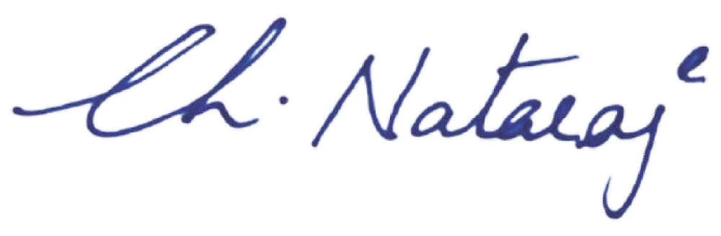

I accept the offer:

By: Sai Kumar Yaramasu

Name: Sai Kumar Yaramasu

Date: 5/9/2022